**GOLD COAST GALLERIA CONDOMINIUM ASSOCIATION**

**111 W. MAPLE, CHICAGO, IL**

**PLUMBING RISER REPLACEMENT**

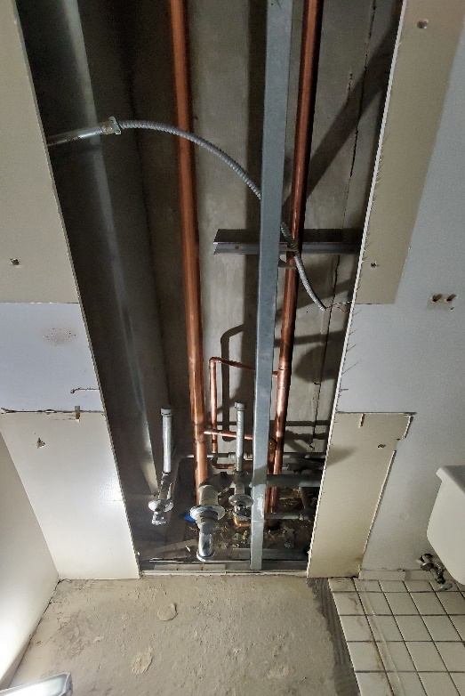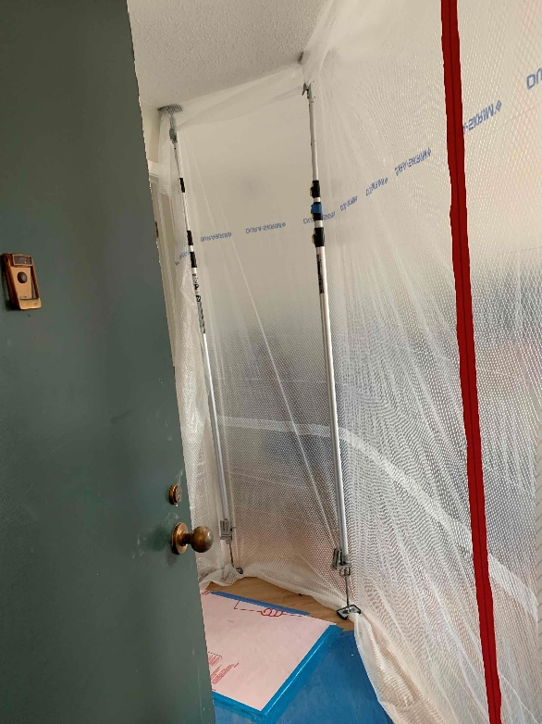

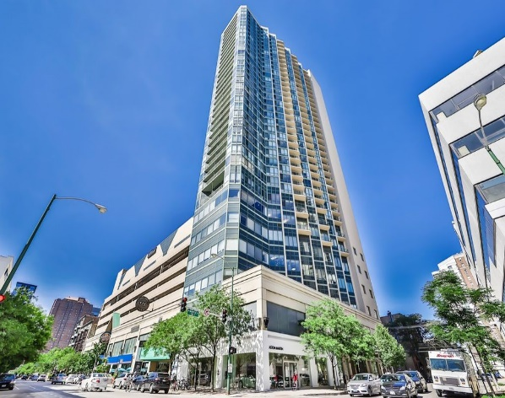

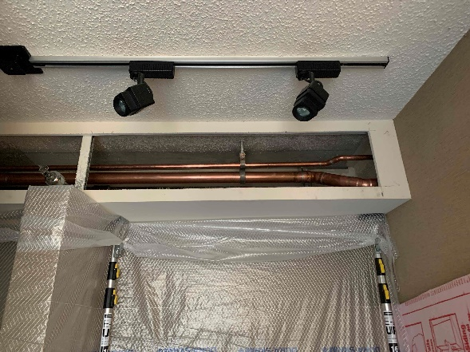

The professionalism was top-notch, polite and listened to our concerns. The quality of work was very good, taking into consideration that all projects have hiccups.... In a nutshell, made my job so much easier. Facilitated the project in an efficient manner, resulting in an on-time completion. Thank you for a job well done!

Becky Kennington

Property Manager

**Reference: Becky Kennington**

**FSR Property Manager**

**Becky.Kennington@fsresidential.com**

​FSPM was engaged by FirstService Residential and the Board at

Gold Coast Galleria Condominium Association to manage this extensive project which replaced the plumbing risers on 34 floors. Work included:

* Obtain all permits, licenses, and approvals
* Coordinate activities/schedule of all subcontractors, including daily COVID-19 screening, including temperature checks, face coverings, sanitizing stations, etc.
* On-site superintendent to ensure project efficiency
* Weekly progress meetings and daily construction reports
* Coordination with unit occupants to minimize conflicts and facilitate occupant usage
* Lobby monitor updating to keep residents informed of the project's progress
* Community coordinator to field calls, emails, etc. from unit owners while scheduling unit work
* Unit protection and final daily cleaning

Horizontal piping was replaced on the 34th, 20th, and 7th floors, as well as the piping within 198 units.

After the piping replacement, the drywall was repaired and repainted in units, corridors, and stairwells.

With cost savings generated by the Project Management team, **$100,000** was returned to the Association.