**2970 N LAKE SHORE DRIVE CONDOMINIUM ASSOCIATION**

**FAÇADE REPAIRS**

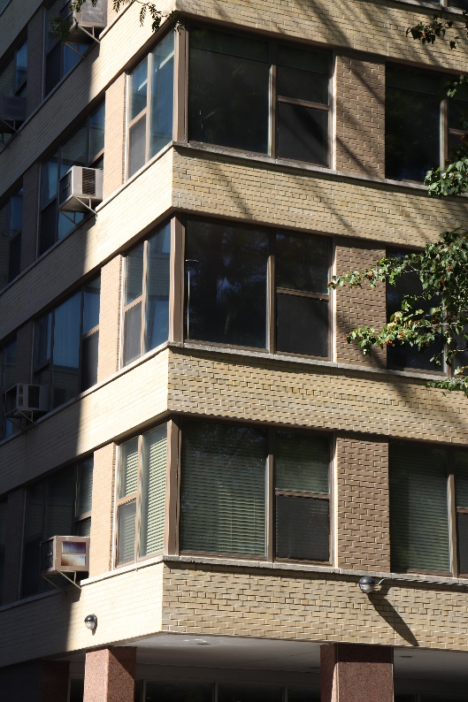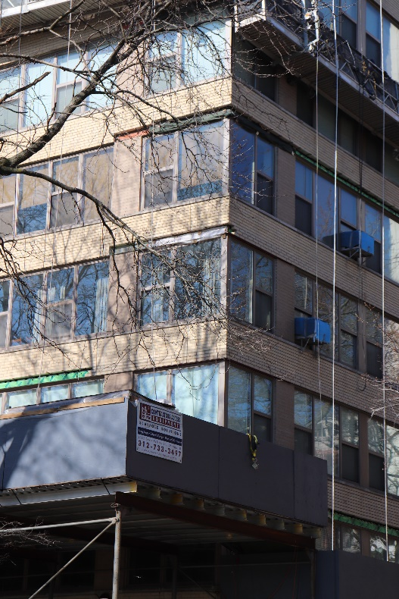

*Communication could not have been better. Extremely satisfied in all regards. FSPM was far superior to any prior work during my time on the board of directors, and as far as I can tell, well before that as well.*

Ron Stevens, Board President

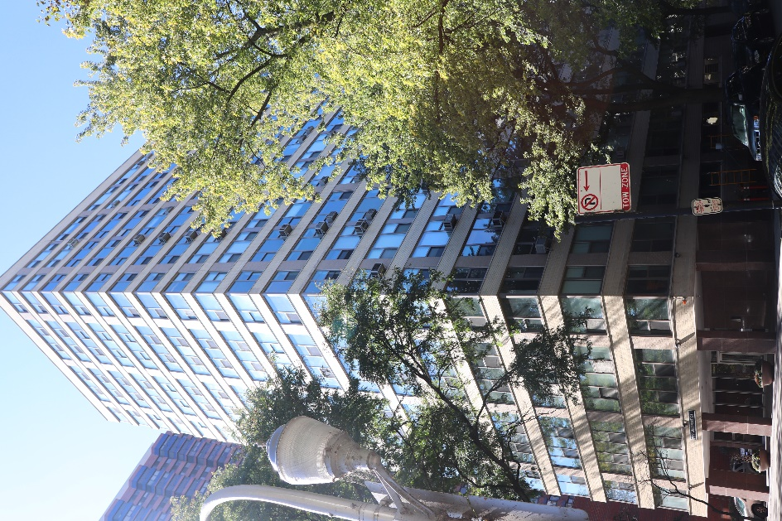

FSPM was engaged by the Association at 2970 N Lake Shore Drive to investigate water infiltration issues. Investigative openings were made after a series of prototype drops to determine where the water was entering the building from and what repairs would be needed to prevent that from happening. FSPM then managed the project repairs which included:

* steel lintel replacement
* flashing installation
* cracked brick/sill replacement
* tuckpointing
* sealant replacement throughout all elevations of the building

FSPM worked with the masonry contractor to develop the project schedule and phasing plan to complete the project in one year. The project started the first week in March 2020 and was complete by the first week in October 2020. The building was split into 13 drops and had 5 swing stages going at a time.

With cost savings generated by the project management team, **$319,000** was returned to the Association and is now being rolled over into a roof replacement project.

**Reference:**

**Karyn Beard, FSR Property Manager**

**Karyn.beard@fsresidential.com**