**TWO RIVER PLACE CONDO ASSOCIATION**

**720 N. LARRABEE, CHICAGO, IL**

**FAÇADE RENOVATION**

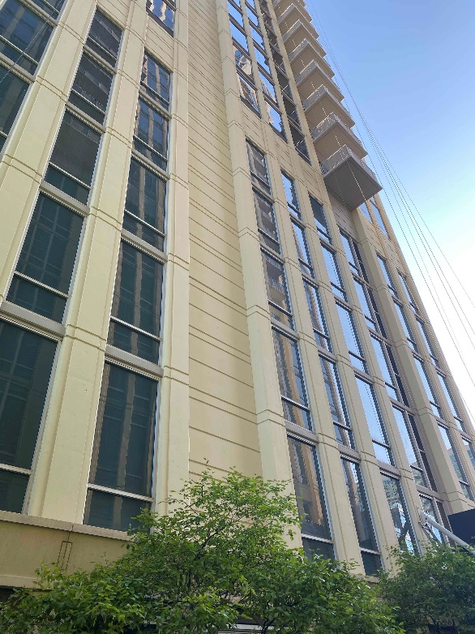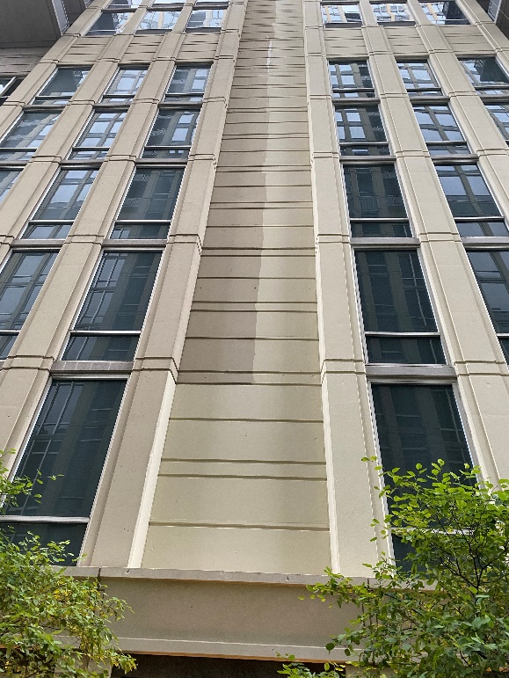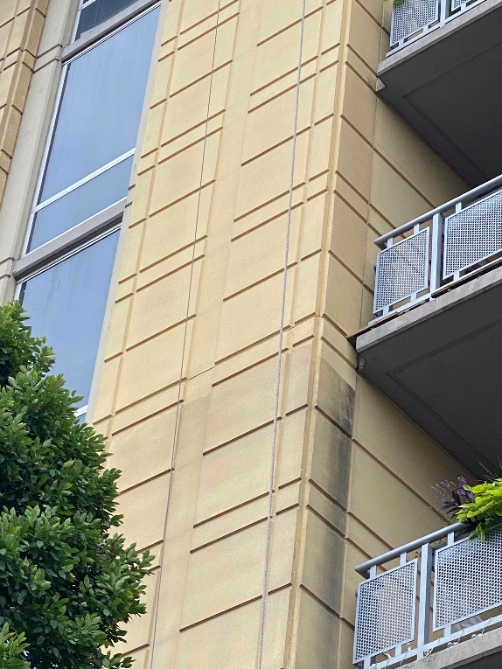

FirstService Project Management was engaged by the Association Board at this Chicago high-rise to manage a critical balcony and facade repair project. The work ranged from simple exterior paint to more complex masonry repairs on this 19-story building. The scope of work included:

* Obtain all permits, licenses, and approvals
* Coordinate activities/schedule of all subcontractors, including daily Covid-19 screening (temperature checks, sanitizing stations, face coverings, etc.)
* On-site superintendent to ensure project efficiency
* Weekly progress meetings and daily construction reports
* Concrete repairs
* Waterproofing membrane repairs
* Sealant repairs
* Concrete painting
* Balcony anchorage replacement
* Cleaning and sealing of existing anchors
* Balcony railing painting

Phasing opportunities allowed our project management team to save the Association a substantial sum of money on this project. By completing the project in one phase, the Association saved roughly **$220,000**.

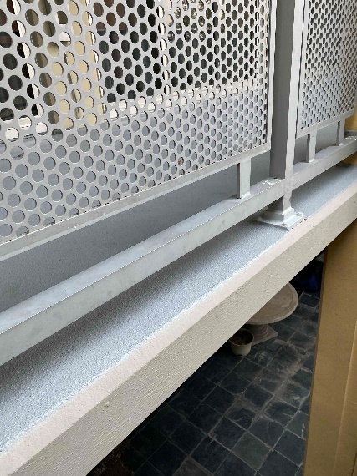

**Reference:**

**Amy Vega, FSR Property Manager | Amy.vega@fsresidential.com**