**MADISON MANOR II CONDO ASSOCIATION**

**910-920 W MADISON, CHICAGO, IL**

**PROTOTYPE REPAIRS**

FSPM had been engaged by the Association at Madison Manor II to perform a critical façade investigation into multiple areas of water infiltration throughout both the 910 and 920 buildings. FSPM has been engaged with Klein & Hoffman throughout the duration of these investigations and have determined that the best course of action would be to move into a prototype repair phase for the atypical repairs that have been identified. These repairs included:

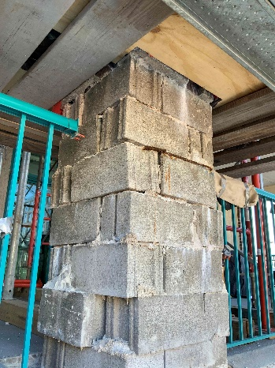

* Removed the existing topping slab and membrane on two of the upper level balconies before sealing the structural panel seams, applying a new underlayment, and coating them with a water-resistant membrane system
* Applied a new finish and weather coating on the parapet wall of one of the upper balconies
* Installed a drip-edge and provided ventilation holes in the structural panels of one of the upper balconies to deflect water away from the building, and allow any trapped water to drain while also allowing the panels to breathe
* Removed and replaced sealant around the sliding door systems at each of the upper level balconies
* Removed, replaced, and resealed damaged clay coping tiles
* Miscellaneous repairs to end caps and panel edges made where necessary to prevent further or future water infiltration
* Removed and replaced the sealant around select windows with western and northern weather exposure
* Removed and replaced the sills undercoating and exterior finish for the selected windows
* Removed and replaced a small section of exterior wall that had experienced water infiltration that was causing damages within a residence
* Applied a new finish and weather coating on the replaced section of exterior wall
* Applied a new water resistant membrane under the replaced exterior wall system that flashed up the wall for better moisture deflection at ground level
* Removed and replaced a 5-story CMU column with steel reinforcing added at each level and cladded in brick the length of the column
* Installed a new masonry cap for the top of the column to better deflect and prevent water infiltration into the column

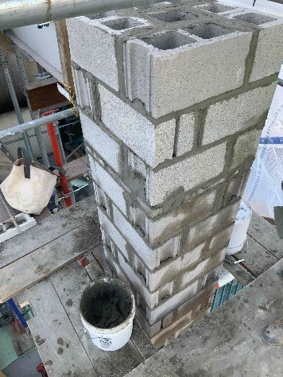

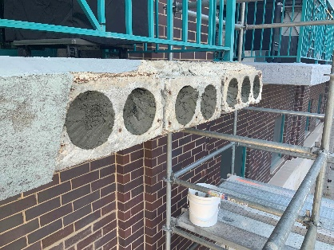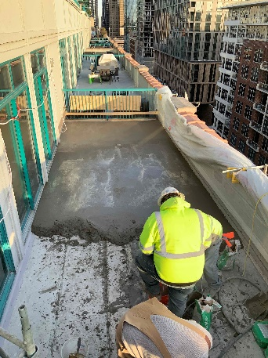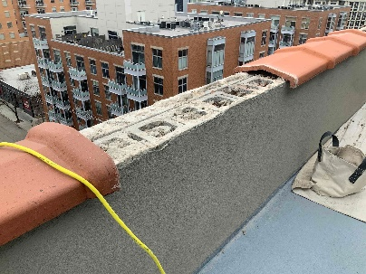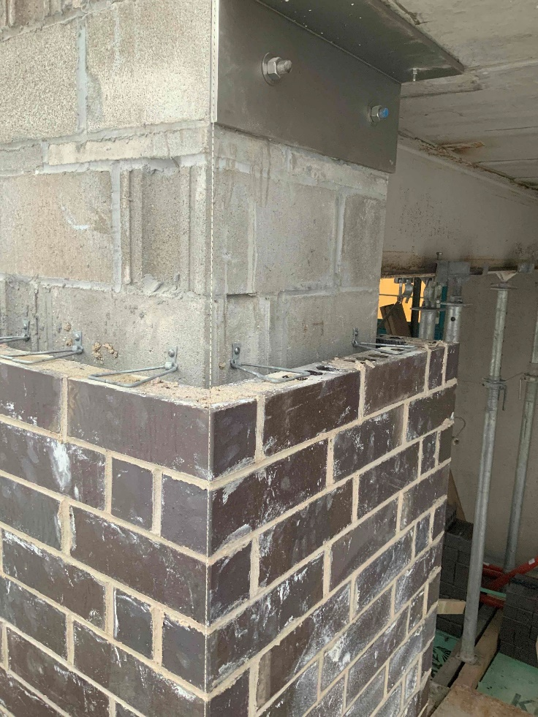

**Reference:**

**Deb O’Hagan, FSR Portfolio Manager**

**Deborah.O’Hagan@fsresidential.com**

Additional observations found concerning conditions, including un-grouted cells, discontinuous vertical/horizontal reinforcing, bearing on brick veneer, erratic CMU installation (with some units placed sideways), insufficient steel beam bearing, etc. Because of this poor construction, the existing CMU column was demolished and a new reinforced CMU column was built.

[Grab your reader’s attention with a great quote from the document or use this space to emphasize a key point. To place this text box anywhere on the page, just drag it.]

[Cite your source here.]