**MADISON MANOR II CONDO ASSOCIATION**

**910-9209 W MADISON, CHICAGO, IL**

**ROOF REPLACEMENT**

FSPM was engaged by FirstService Residential and the Board at Madison Manor II Condo Association to manage this extensive project which replaced the existing TPO and EPDM roofing systems with a new SBS modified Bitumen roofing system at the main roof and penthouse.

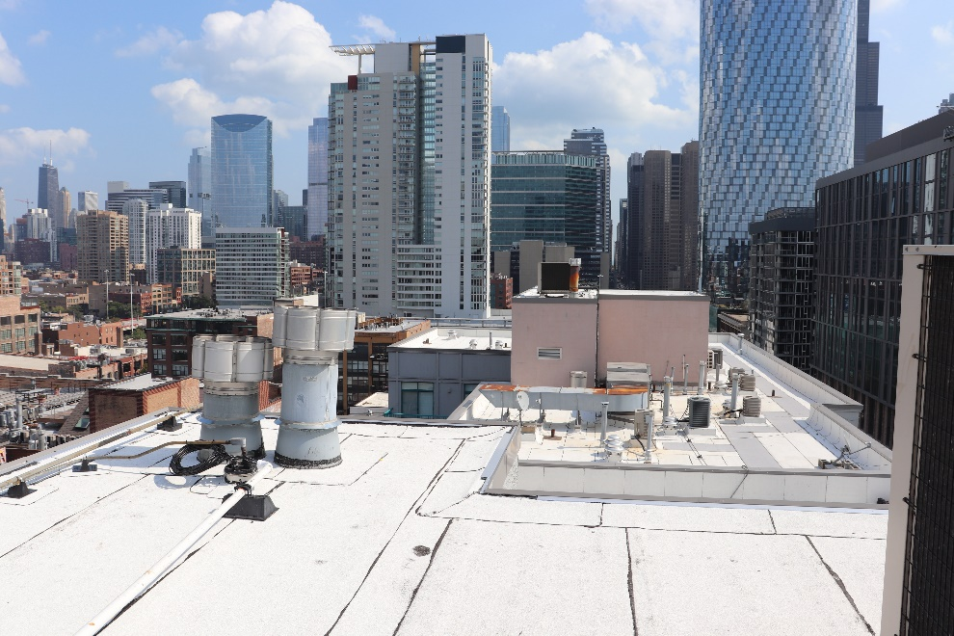

Work included:

* Obtain all permits, licenses, and approvals
* Coordinate activities/schedule of all subcontractors
* On-site superintendent to ensure project efficiency
* Weekly progress meetings and daily construction reports
* Coordination with unit occupants to minimize conflicts and facilitate occupant usage
* Lobby monitor updating to keep residents informed of the project's progress

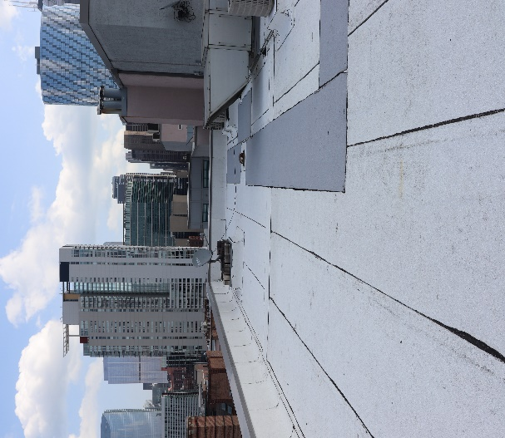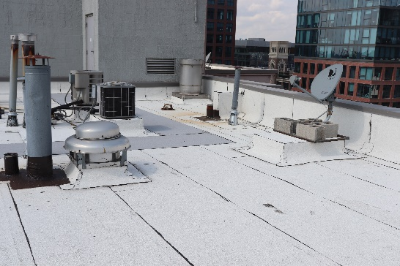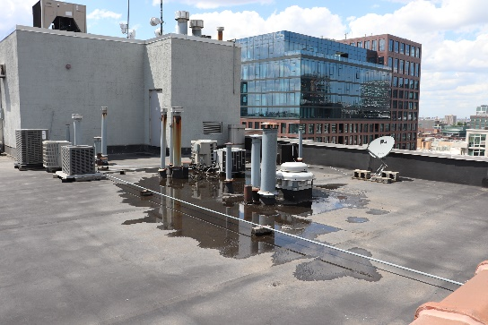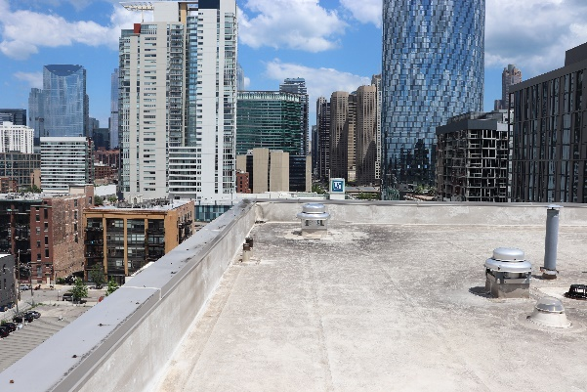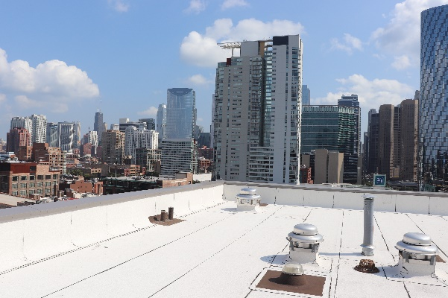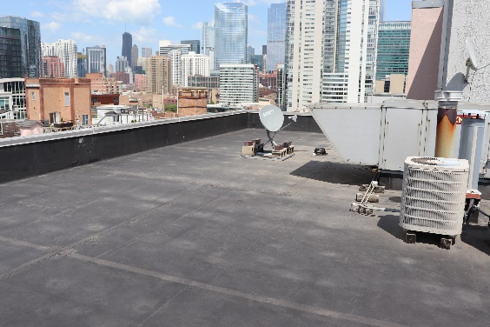

**AFTER**

**BEFORE**

**Reference: Deb O’Hagan, FSR Portfolio Manager**

**Deborah.O’Hagan@fsresidential.com**